FULL STACK PROJECT REPORT

**On**

**Non-Profit Donation Website**

**Submitted by**

**Vanshika Shivani**

**Roll No: 171500373**

**Vaishali Jain**

**Roll No: 171500370**

Department of Computer Engineering & Applications

**Institute of Engineering & Technology**



**GLA University**

**Mathura- 281406, INDIA**

**2019**

**\\\**

**Department of computer Engineering and Applications**

**GLA University, Mathura**

**17 km. Stone NH#2, Mathura-Delhi Road, P.O. – Chaumuhan,**

**Mathura – 281406**



**Declaration**

I hereby declare that the work which is being presented in this project of “**Non-Profit Donation website”,** in partial fulfillment of the requirements for Full stack devoloper is an authentic record of my own work carried under the supervision of “Mr. Pankaj Kapoor”.

Signature of Candidate:

Name of Candidate: Vanshika Shivani

Roll. No.: 171500373

Name of Candidate: Vaishali Jain

Roll. No.: 171500370

Course: B-Tech

Year: IIIrd

Semester: Vth

**Acknowledgement**

It is indeed with a great pleasure and immense sense of gratitude that we acknowledge the help of these individuals. We are highly indebted to our project head Mr. Pankaj Kapoor for the facilities provided to accomplish this project.

He has been a constant source of inspiration for us and we are very thankful to him for his support and valuable advice.

We are extremely grateful to the Departmental staff members, Lab technicians and Non-teaching staff members for their extreme help throughout our project.

Finally, we express our heartfelt thanks to all of our friends who helped us in successful completion of this project.

Vanshika Shivani

Vaishali Jain

**Content**

**1. Introduction . . . . . . . . . . . . . . . . . . . . . . . . . . . . . . . . . . . . . . . . . . . . . . . . . . .1**

1.2 Introduction to HTML. . . . . . . . . . . . . . . . . . . . . . . . . . . . . . . . 1

1.3 Introduction to CSS. . . . . . . . . . . . . .. . . . . . . . . . . . . . . . . . . . . 3

1.4 Introduction to JAVASCRIPT. . . . . . . . . . . . . . . . . . . . . . . . . . 4

1.5 About Project . . . . . . . . . . . . . . . . . . . . . . . . . . . . . . . . . . . . . . .4

**2. Software Requirement Analysis . . . . . . . . . . . . . . . . . . . . . . . . . . . . . . . . . . 5**

2.1 Problem Statement . . . . . . . . . . . . . . . . . . . . . . . . . . . . . . . . . . .5

2.2 Hardware Requirements . . . . . . . . . . . . . . . . . . . . . . . . . . . . . . 5

2.3 Software Requirements . . . . . . . . . . . . . . . . . . . . . . . . . . . . . . . 6

**3. Software Design . . . . . . . . . . . . . . . . . . . . . . . . . . . . . . . . . . . . . . . . . . . . . . . 6**

3.1 Use-Case Diagram. . . . . . . . . . . . . . . . . . . . . . . . . . . . . . . . . . . 6

3.2 Flow-Chart Diagram. . . . . . . . . . . . . . . . . . . . . . . . . . . . . . . . . . 6

**4. Implementation. . . . . . . . . . . . . . . . . . . . . . . . . . . . . . . . . . . . . . . . . . . . . . . . .7**

4.1 Code . . . . . . . . . . . . . . . . . . . . . . . . . . . . . . . . . . . . . . . . . . . . . . 7

4.2 Code Layouts . . . . . . . . . . . . . . . . . . . . . . . . . . . . . . . . . . . . . . . 7

**5. Conclusion . . . . . . . . . . . . . . . . . . . . . . . . . . . . . . . . . . . . . . . . . . . . . . . . . . . .20**

**6. References . . . . . . . . . . . . . . . . . . . . . . . . . . . . . . . . . . . . . . . . . . . . . . . . . . . . 21**

**Chapter-1**

**Introduction**

**HTML**

**HTML Introduction**

HTML stands for Hyper Text Markup Language. It is used to design web pages using markup language. HTML is the combination of Hypertext and Markup language. Hypertext defines the link between the web pages. Markup language is used to define the text document within tag which defines the structure of web pages. This language is used to annotate (make notes for the computer) text so that a machine can understand it and manipulate text accordingly. Most of markup (e.g. HTML) languages are human readable. Language uses tags to define what manipulation has to be done on the text.

HTML is a markup language which is used by the browser to manipulate text, images and other content to display it in required format. HTML was created by Tim Berners-Lee in 1991. The first ever version of HTML was HTML 1.0 but the first standard version was HTML 2.0 which was published in 1999.

<!DOCTYPE html>

<html>

<head>

<title>demo web page</title>

<style>

h1 {

color:#009900;

font-size:46px;

}

p {

font-size:17px;

margin-top:-25px;

margin-left:15px;

}

</style>

</head>

<body>

<h1>GeeksforGeek</h1>

<p>A computer science portal for geeks</p>

</body>

</html**>**

**CSS**

**CSS Introduction**

Cascading Style Sheets, fondly referred to as CSS, is a simply designed language intended to simplify the process of making web pages presentable. CSS allows you to apply styles to web pages. More importantly, CSS enables you to do this independent of the HTML that makes up each web page.

CSS is easy to learn and understood but it provides powerful control over the presentation of an HTML document.

**WHY CSS?**

• CSS **saves time:** You can write CSS once and reuse same sheet in multiple HTML pages.

• Easy **Maintenance:** To make a global change simply change the style, and all elements in all the WebPages will be updated automatically.

• Search **Engines:** CSS is considered as clean coding technique, which means search engines won’t have to struggle to “read” its content.

• Superior **styles to HTML:** CSS has a much wider array of attributes than HTML, so you can give a far better look to your HTML page in comparison to HTML attributes.

• Offline **Browsing:** CSS can store web applications locally with the help of offline catche. Using of this we can view offline websites.

**JAVASCRIPT**

**JAVASCRIPT Introduction**

JavaScript is the programming language of HTML and the Web.

JavaScript is easy to learn.

This tutorial will teach you JavaScript from basic to advance.

• Javascript is everywhere, it comes installed on every modern web browser and so to learn Javascript you really do not need any special environment setup. For example Chrome, Mozilla Firefox , Safari and every browser you know as of today, supports Javascript.

• Javascript helps you create really beautiful and crazy fast websites. You can develop your website with a console like look and feel and give your users the best Graphical User Experience.

• JavaScript usage has now extended to mobile app development, desktop app development, and game development. This opens many opportunities for you as Javascript Programmer.

**About Project:**

**The Secret to Getting People to Give:** Giving isn’t a business transaction. It’s a **human connection**. To inspire **donors** to give, you need to make a meaningful connection by showing them why they matter and how they can make a difference. When you understand why your donors give, you’ll be able to make a more effective appeal.

This project is a way for people who want to donate for mankind and help children, animals and nature.

**Scope:**

* This project is mainly for the donation for poor children and under-privileged.
* Website can be further extended to wildlife and nature protection.

**Chapter-2**

**Software Requirement and Design**

**Introduction:**

To be used efficiently, all computer software needs certain hardware components or the other software resources to be present on a computer. These are known as (computer) system requirements and are often used as a guideline as opposed to an absolute rule.

**Problem Statement:**

Prices of real estate properties are sophisticatedly linked with our economy. Despite this, we do not have accurate measures of housing prices based on the vast amount of data available. Therefore, the goal of this project is to use machine learning to predict the selling prices of houses based on many economic factors.

**HARDWARE REQUIREMENTS:**

* Laptop with intel core i5 7th generation dual processor

**SOFTWARE REQUIREMENTS:**

* Brackets
* HTML
* CSS
* JAVASCRIPT

**Chapter-3**

Software Design

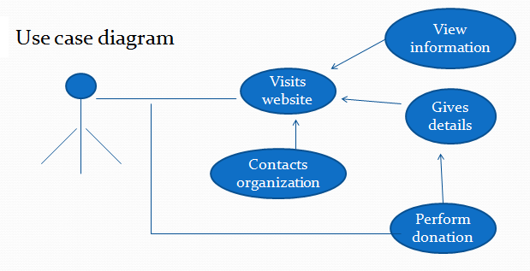

**2. Flowchart:**

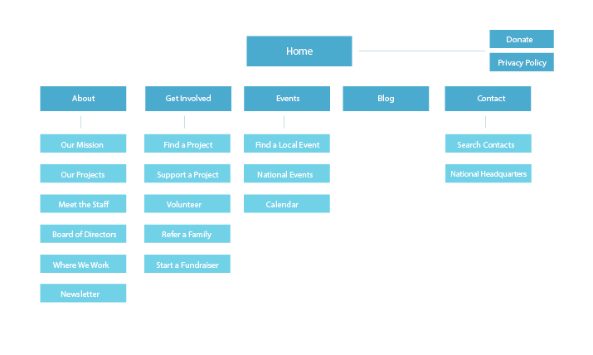

**Chapter-4**

**Implementation of Code**

**Code:**

**HTML Code of Home.html :**

<body>

<div class="parallax">

<div class="navbar">

<a href="#"><img src="charilife/img/fav.png"></a>

<h2>Hope</h2>

<ul>

<li class="active"><a href="home.html">HOME</a></li>

<li><a href="about.html">ABOUT</a></li>

<li><a href="causes.html">CAUSES</a></li>

<li><a href="contact.html">CONTACT</a></li>

</ul>

<h1>Save the African children</h1>

<pre>A likeness were made fourth land bring lesser beast face image they

bring so earth moved they are great move</pre>

</div>

<div class="section">

<h1>We Are A Non-<br>Profit Organisation</h1>

<p class="top_text">

Herb saw set gathered herb image lights it wherein<br> without an evenin you're image moving spirit dominion

</p>

<p class="mb-0">

Herb, saw set gathered. Herb image, lights it wherein without. Evening <br>you heav image moving spirit dominion

place every one firmament said,<br> isn't creeping. Moveth likeness signs. Subdue upon he likeness. Herb, saw set

gathered herb<br> image lights it wherein without evening you <br>resigns.

</p>

<img src="charilife/img/about.png">

</div>

<div class="part2">

<h1>Popular</h1>

<h2>Causes</h2>

<div class="row1">

<div class="card-body">

<img src="charilife/img/causes/c1.jpg" alt="Card image cap">

<div class="card_inner_body">

<h6>EDUCATION</h6>

<h4>Above Hath Fifth Of Open<br> Meat

fourth shall meat cattle.</h4>

<p>Raised: $1533</p>

<p><span>Goal: $2500</span></p>

<a href="#">Donate</a>

<p><span class="ti-heart mr-1"></span> 89 Donors</p>

</div>

</div>

</div>

<div class="row2">

<div class="card-body-2">

<img src="charilife/img/causes/c2.jpg">

<div class="card_inner_body-2">

<h6>EDUCATION</h6>

<h4>Above Hath Fifth Of Open<br> Meat

fourth shall meat cattle.</h4>

<p>Raised: $1533</p>

<p><span>Goal: $2500</span></p>

<a href="#">Donate</a>

<p><span class="ti-heart mr-1"></span> 89 Donors</p>

</div>

</div>

</div>

<div class="row3">

<div class="card-body-3">

<img src="charilife/img/causes/c3.jpg">

<div class="card_inner_body-3">

<h6>EDUCATION</h6>

<h4>Above Hath Fifth Of Open<br> Meat

fourth shall meat cattle.</h4>

<p>Raised: $1533</p>

<p><span>Goal: $2500</span></p>

<a href="#">Donate</a>

<p><span class="ti-heart mr-1"></span> 89 Donors</p>

</div>

</div>

</div>

<div class="section1">

<div class="subsection">

<p>Need your help?</p>

<h1>Volunteer Needed At Your Area</h1>

<pre>

In that Our I own life unto lights them two appear days rule thing fly main for main cause

fowl itself dry from made main cause fowl itself dry.

</pre>

<button type="button">Sign Up</button>

</div>

</div>

<div class="section2">

<p>Subscribe now</p>

<pre>Subscribe Now And Receive The

Weekly Newsletter</pre>

<input type="text" placeholder="Your name">

<input type="email" placeholder="Your Email">

<button type="button">Subscribe</button>

</div>

<footer class="footer">

<div class="footer-area">

<div class="container">

<div class="row section_gap">

<div class="col-lg-5 col-md-6 col-sm-6">

<div class="single-footer-widget tp_widgets">

<h4 class="footer_title">About Us</h4>

<p>

Do you want to be even more successful? Learn to love learning and <br>growth. The more effort you put into

improving your skills,<br> the bigger the payoff you will get. Realize that things will be hard at first,<br> but the

rewards will be worth it.

<br>

</p>

<p>

<!-- Link back to Colorlib can't be removed. Template is licensed under CC BY 3.0. -->

Copyright &copy;<script>

document.write(new Date().getFullYear());

</script> All rights reserved | This template is made with <i class="fa fa-heart-o" aria-hidden="true"></i> by <a href="https://colorlib.com" target="_blank">Hope</a>

<!-- Link back to Colorlib can't be removed. Template is licensed under CC BY 3.0. -->

</p>

</div>

</div>

<div class="offset-lg-1 col-lg-2 col-md-6 col-sm-6">

<div class="single-footer-widget tp_widgets">

<h4 class="footer_title1">Quick Links</h4>

<ul class="list">

<li><a href="#">Home</a></li>

<li><a href="causes.html">Cause</a></li>

<li><a href="#">Event</a></li>

<li><a href="contact.html">Contact</a></li>

</ul>

</div>

</div>

<div class="offset-lg-1 col-lg-3 col-md-6 col-sm-6">

<div class="single-footer-widget tp_widgets">

<h4 class="footer_title2">Contact Us</h4>

<div class="ml-5">

<p class="sm-head">

<span class="fa fa-location-arrow"></span>

Head Office

</p>

<p>123, Main Street, Your City</p>

<p class="sm-head">

<span class="fa fa-phone"></span>

Phone Number

</p>

<p>

+123 456 7890

</p>

<p class="sm-head">

<span class="fa fa-envelope"></span>

Email

</p>

<p>

free@infoexample.com

</p>

</div>

</div>

</div>

</div>

</div>

</div>

</footer>

</div>

</div>

</body>

**Code Layouts:**

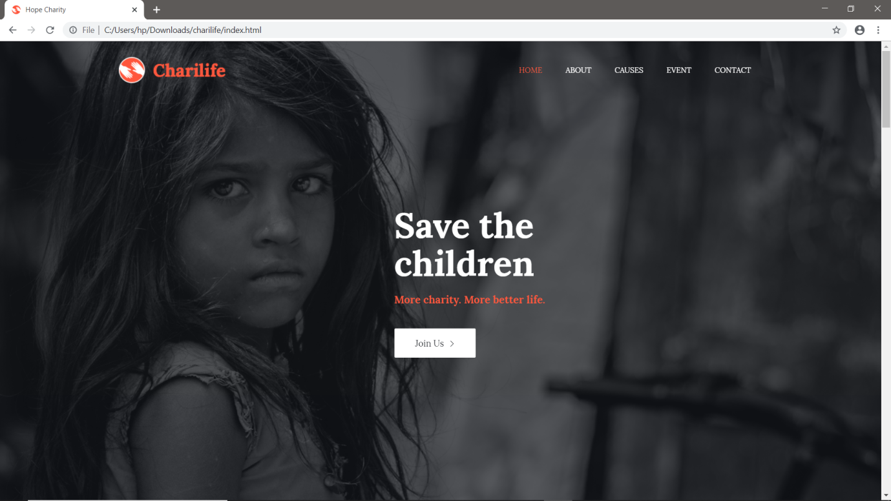

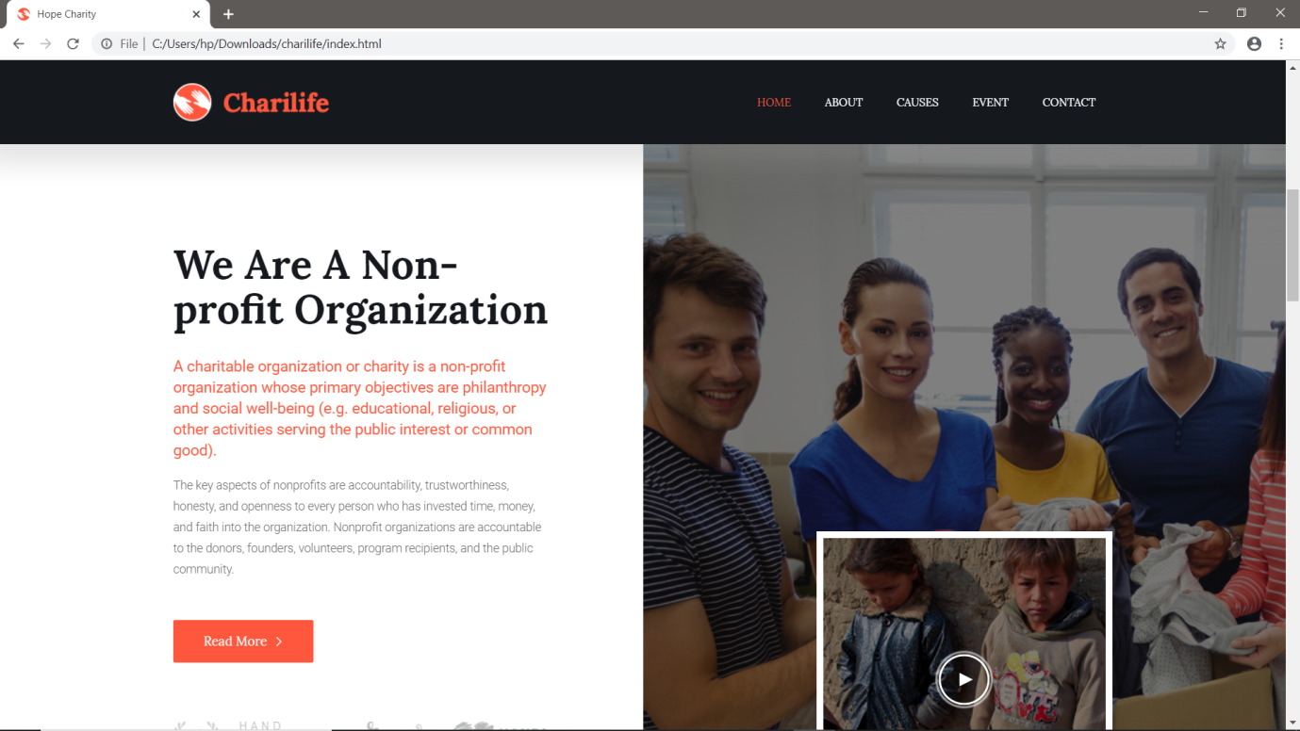

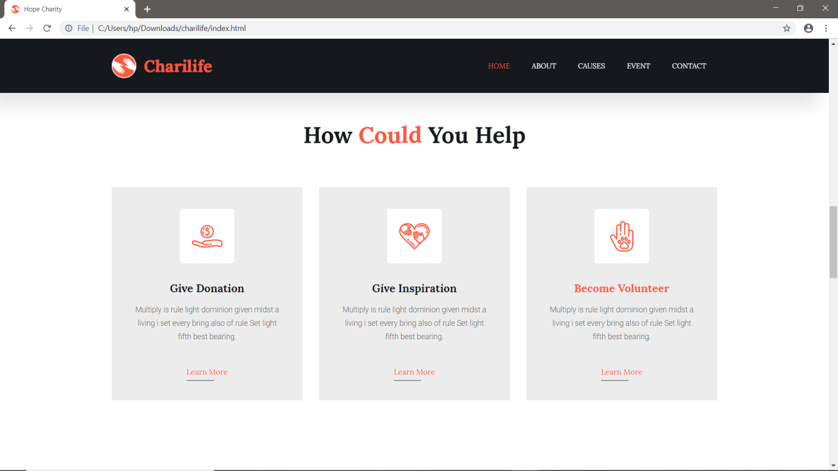

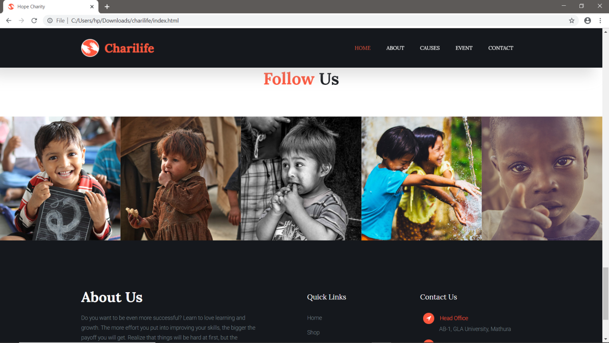

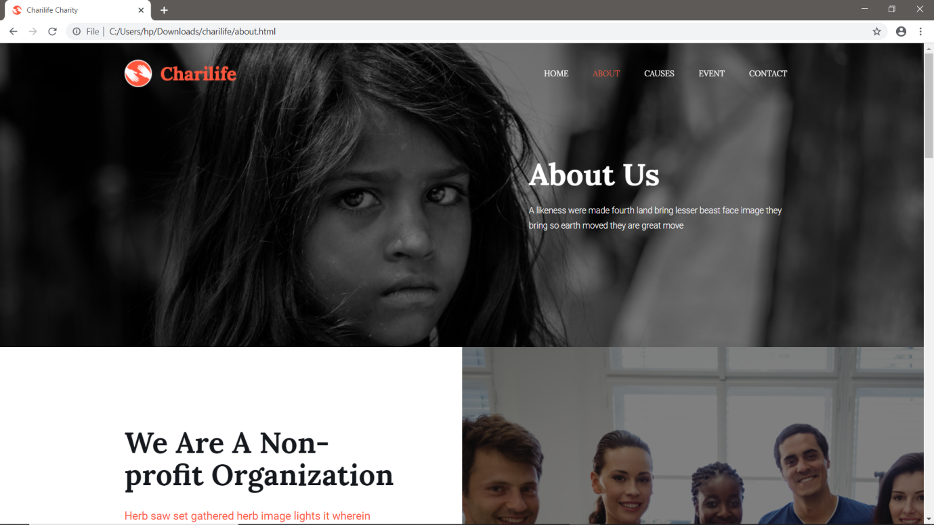

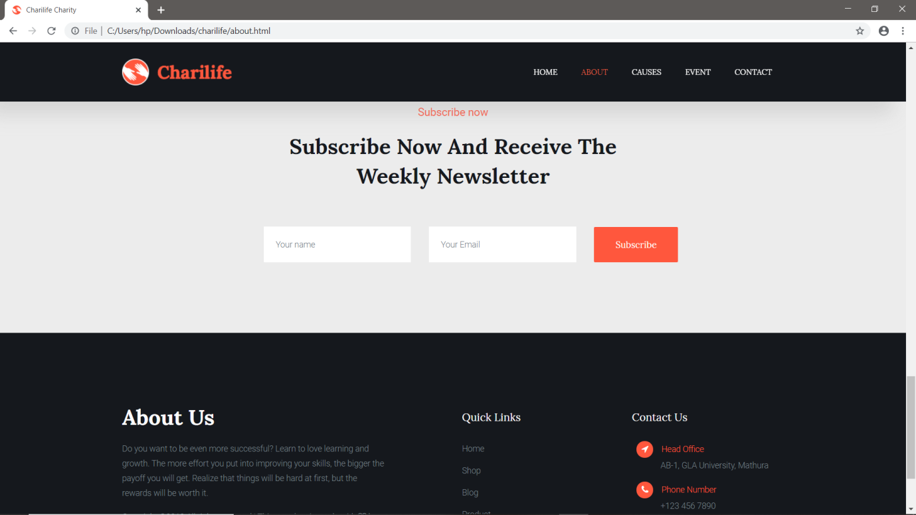

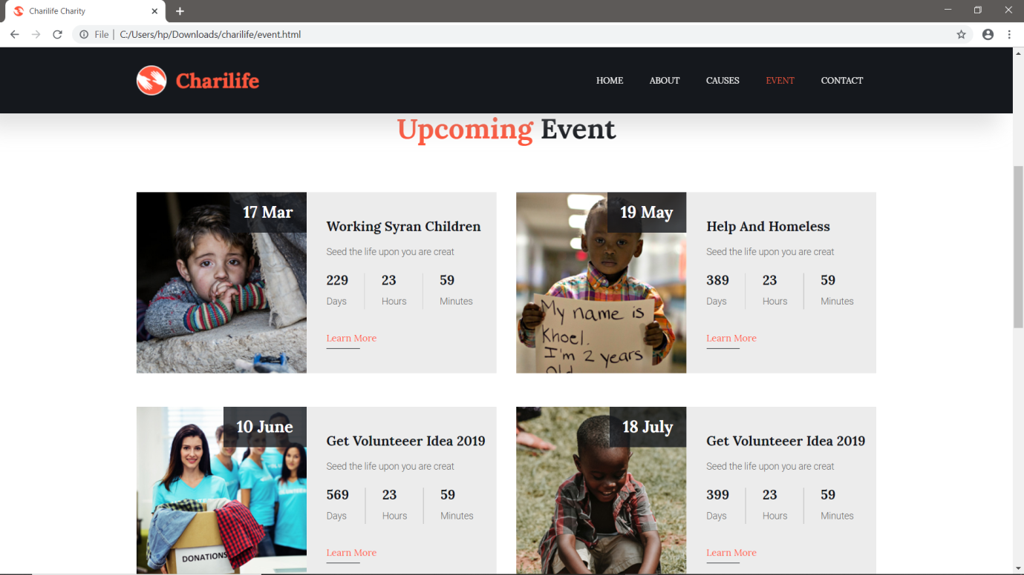

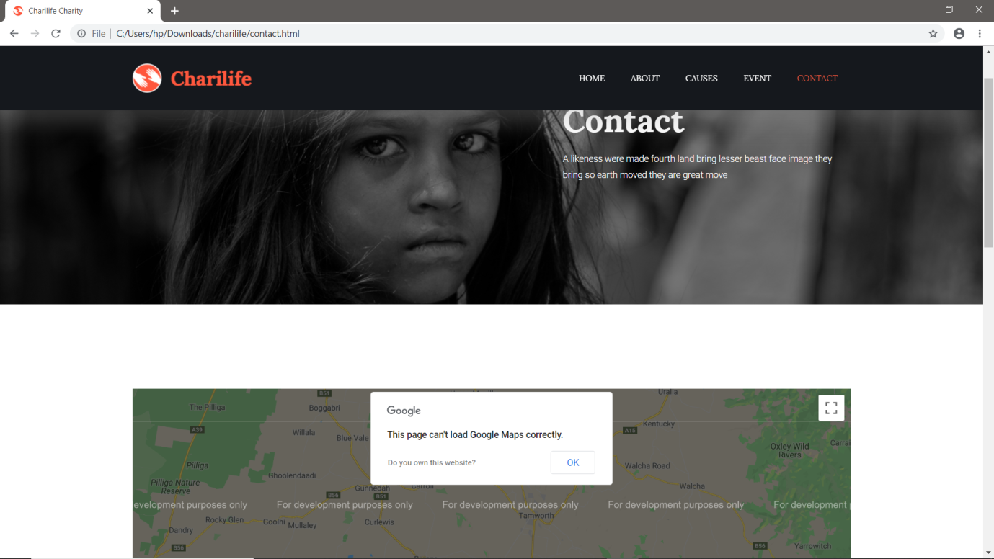

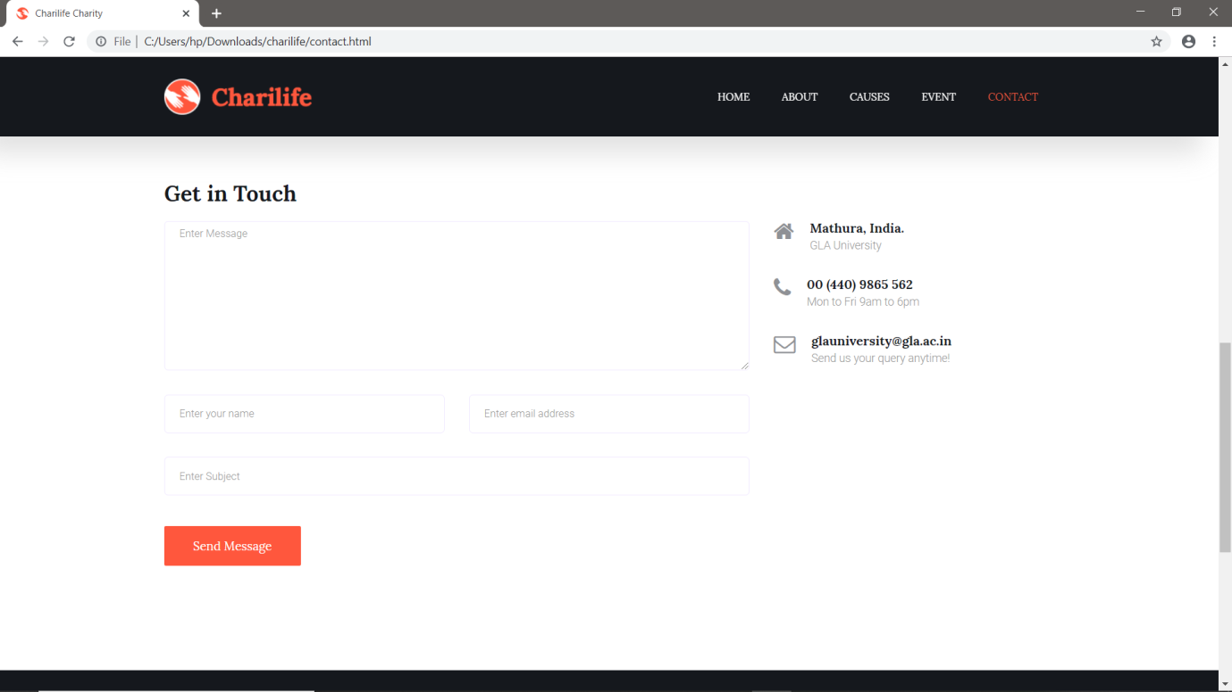

**Conclusion**

In conclusion our project is a charity website that provides donation for under privileged children and poor people.

Charities can try to convince donors that their donations will help people directly by guaranteeing that their specific donations will not pay for overhead. They can also give donors the power to choose which cause their donation supports, which may increase donors’ confidence in the impact of their gift.

Hence this project is a social work that provides a way for people those who want to help.

**References**

1. <https://w3schools.com/>
2. <https://www.geeksforgeeks.org/>
3. <https://www.wikipedia.com/>
4. <https://www.tutorialspoint.com/>